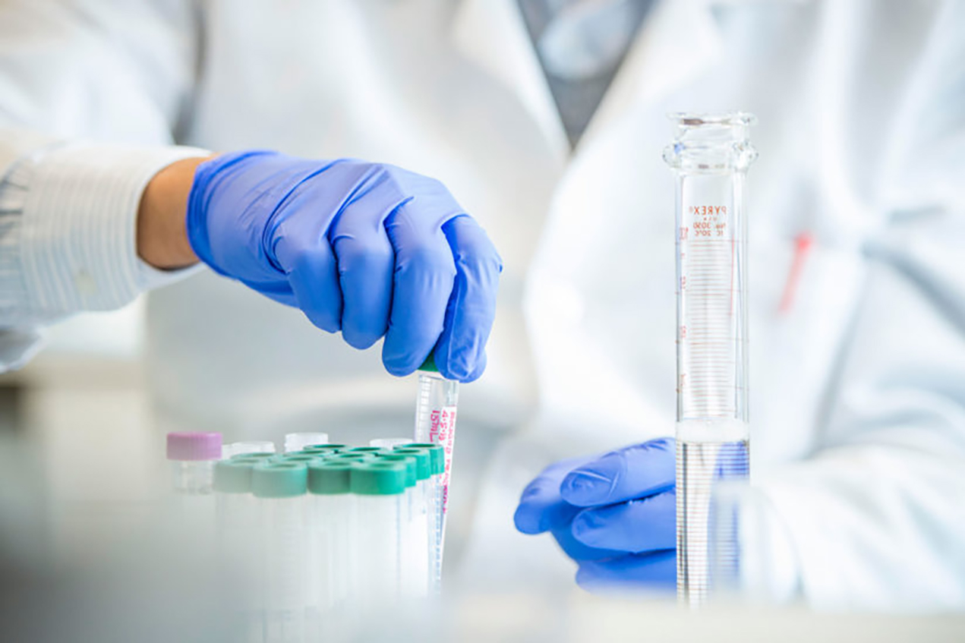



STUDENT RECOGNITION

AWARDS

Application Form 2020-2021

COP SRA 2020-2021

**College of Pharmacy Student Recognition Awards**

1. **Applicant**

|  |  |  |  |  |  |
| --- | --- | --- | --- | --- | --- |
| SURNAME | Click or tap here to enter text. | GIVEN NAME | | Click or tap here to enter text. | |
| STUDENT ID | Click or tap here to enter text. | EMAIL | Click or tap here to enter text. | | |
| MOBILE | Click or tap here to enter text. | FIRST ENROLMENT DATE | | | Click or tap here to enter text. |

1. **Award category applied for (choose ONE or MULTIPLE)**

|  |  |  |
| --- | --- | --- |
| 1 | COP SRA for Research Excellence |  |
| 2 | COP SRA for Outstanding Academic Performance |  |
| 3 | COP SRA for Distinguished Community Service |  |

1. **Briefly explain why you should be considered for the nominated award and what sort of impact will this have on you if your application is successful (No more than 150 words)**

|  |
| --- |
| Click or tap here to enter text. |

APPLICATION FORM

1. **Description of your achievements against the award category/categories (No more than 150 words per category)**

|  |
| --- |
| *COP SRA for Research Excellence (insert n/a if not applying for this category)* |
| Click or tap here to enter text. |
| *COP SRA for Outstanding Academic Performance (insert n/a if not applying for this category)* |
| Click or tap here to enter text. |
| *COP SRA for Distinguished Community Service (insert n/a if not applying for this category)* |
| Click or tap here to enter text. |

APPLICATION FORM

1. **Nominated Referee Information**

|  |  |
| --- | --- |
| TITLE | Click or tap here to enter text. |
| FULL NAME | Click or tap here to enter text. |
| EMAIL | Click or tap here to enter text. |
| PHONE # | Click or tap here to enter text. |
| DEPARTMENT | Click or tap here to enter text. |
| INSTITUTIONAL ADDRESS | Click or tap here to enter text. |

1. **Applicant Declaration**

I certify that the information provided in this application is true and correct.

|  |  |  |  |
| --- | --- | --- | --- |
| NAME | Click or tap here to enter text. | **SIGNATURE** |  |
| DATE | Click or tap here to enter text. |

Note: Insert your signature as picture.

APPLICATION FORM

**FOR OFFICE USE ONLY**

1. **PANEL RECOMMENDATION**

|  |  |  |  |
| --- | --- | --- | --- |
| **APPLICATION COMPLETE** | | | |
| YES | | NO | |
| **DECISION** | | | |
| ACCEPT | | REJECT | |
| **APPROVED AWARD CATEGORY (IF ANY)** | | | |
| COP SRA for Research Excellence | | |  |
| COP SRA for Outstanding Academic Performance | | |  |
| COP SRA for Distinguished Community Service | | |  |
| **COMMENTS (IF ANY)** | | | |
| Click or tap here to enter text. | | | |
| **PANEL MEMBER** | **DATE** | | **SIGNATURE** |
| Click or tap here to enter text. | Click or tap here to enter text. | |  |
| Click or tap here to enter text. | Click or tap here to enter text. | |  |
| Click or tap here to enter text. | Click or tap here to enter text. | |  |

1. **AWARD COORDINATOR ENDORSEMENT**

|  |  |  |  |
| --- | --- | --- | --- |
| NAME | Click or tap here to enter text. | **SIGNATURE** |  |
| DATE | Click or tap here to enter text. |

1. **COLLEGE DEAN ENDORSEMENT**

|  |  |  |  |
| --- | --- | --- | --- |
| NAME | Click or tap here to enter text. | **SIGNATURE** |  |
| DATE | Click or tap here to enter text. |

APPLICATION FORM

**Contact Us**

**Dr. Ibrahim Mohammad Salman**

Student Award Coordinator

Email: [isalman@alfaisal.edu](mailto:malfagih@alfaisal.edu)

Tel: +966-11-215-8819

**Alfaisal University © 2020**



